**Software Engineering**

Select Device

Select Tariff

Select Start Time

Select End Time

Remove Device

Graph

Cost Estimate

Total Power Estimate

Device Estimate

End_system

Start_system

User

Clear All

Add to Estimate

Calculate Estimate

Generate Graphs

**Context Diagram**

**Data Dictionary**

Start_system = /* Launches the system.

Select_device = {Device Name, Power_value}10

Select_tariff = {Price}2

Select_start_time = /* Select time device was turned on, type double

Selec_end_time = /* Select time device was turned off, type double

Add_to_estimate = /* Saves all values: price, time and power

Generate_graph = /* Generates graph

Clea_all = /* Resets all fields and values

Remove_device = /* Remove device from estimate

Graph = /* Displays graph to user

Total_cost = /* Requests calculation

Total_power = /* Requests calculation

Device_power = /* Power used by device, type double

Device_name = /* Name of device, type string

Price = /* Price of tariff, type double

End_system = /* Stops the system

**Data Flow Diagram**

Duration

Power

Price

Start time

Start time

Start time

End time

End time

Power

Start time

Get start time

Get power

(T)

(T)

(T)

(T)

(T)

(T)

Total Energy use

Total cost

Graph

End_system

Start_system

Total cost estimate

Total power estimate

Generate graph

Remove device

Add device

Select Tariff

Select End Time

**Pseudo-Code**

|  |
| --- |
| **Get Power**  Alias: SelectDevice_SelectedIndexChanged  Input: None  Power from Power_txt  Output: Power |
| **Get Price**  Alias: SelecTariff_SelectedIndexChanged  Input: None  Price from hardcoded values  Output: Price |
| **Get Start Time**  Alias: StartTime_SelectedIndexChanged  Input: None  Start time from StartTime  Output: Start time |
| **Get End Time**  Alias: EndTime_SelectedIndexChanged  Input: None  End time from EndTime  Output: End time |
| **Calculate Duration**  Alias: Add_Device_btn_btn_Click  Input: Start time, End Time  Duration = End time – Start Time  Output: None |
| **Calculate Total Cost**  Alias: Calculate_btn_Click  Input: Price, Power, Duration  Cost of each device = Price * Power * Duration  Total cost = sum of all devices  Output: None |
| **Calculate Total Energy**  Alias: Calculate_btn_Click  Input: Power, Duration  energy of each device = Power * Duration  Total energy = sum of all energy  Output: None |
| **Generate Graph**  Alias: Generate_Graph_btn_Click  Input: Power, start time, end time  Plot points (start time, power) and (end time, power)  Output: None |

**User Experience Design**

The way in which the form is displayed to the user is paramount to the end experience. There should be some sort of logical flow, guiding the user through the experience. Left-to-right and top to bottom are how most, if not all, of the end users of this software will naturally read. It is therefore important that the information and inputs are laid out in this particular fashion to try and reduce or eliminate any confusion.

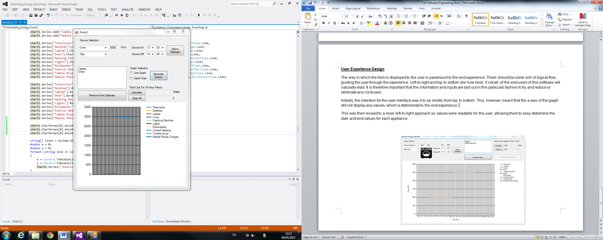Initially, the intention for the user interface was it to be mostly from top to bottom. This, however, meant that the x-axis of the graph did not display any values, which is detrimental to the end experience.

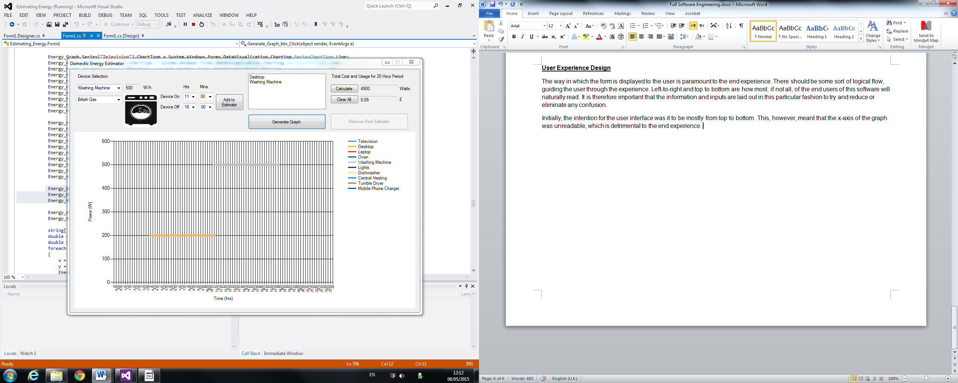This was then revised to a more left-to-right approach so values were readable for the user, allowing them to easy determine the start and end values for each appliance.